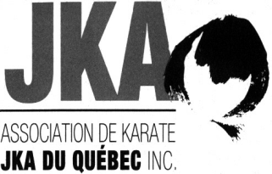 | AKJKAQ Summer Training Camp  June 27 to July 1, 2018  www.akjkaq.ca
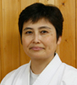 | Guest instructor:  Sensei Yuko Hirayama  6th dan, Japan  View Details  at the Palestre of the École de technologie supérieure, Building B, 1111, Notre-Dame West, Montreal (corner Peel). From ground level, take elevator to third floor.  How to get there : http://en.etsmtl.ca/en/Overview/Contact-Us
SCHEDULE
Wednesday |  | 9h30 à 10h30 | All
June 27, 2018 |  | 10h30 à 11h00 | Black belts Katas (Tekki Nidan, Sochin)
 |  | 16h00 à 17h30 | All
Thursday |  | 9h30 à 10h30 | All
June 28, 2018 |  | 10h30 à 11h00 | Blacks belts Katas (Tekki Sandan, Nijushiho)
 |  | 16h00 à 17h30 | All
Friday |  | 9h30 à 10h30 | All
June 29, 2018 |  | 10h30 à 11h00 | Black belts Katas (Hangetsu, Jitte)
 |  | 16h00 à 17h30 | All
Saturday |  | 9h30 à 10h30 | All
June 30, 2018 |  | 10h30 à 11h00 | Black belts Katas (Kanku Sho, Bassai Sho)
 |  | 16h00 à 17h30 | All
 |  | 19h00 à 22h00 | Party
Sunday |  | 9h30 à 10h30 | All
July 1, 2018 |  | 10h30 à 11h00 | Black belts Katas (Chinte, Gojushio Sho)
 |  | 11h00 à 12h30 | Dan examinations
Rules regarding the use of cameras, videos, cellulars, etc. during AKJKAQ activities.

It is strictly forbidden to photograph, film or take pictures with any device without permission from AKJKAQ.

For more information, please contact Jean-Pierre Cusson by email karate.jka@videotron.ca or by phone (450) 441-1061.

